NAME:- V S SRAVAN M

ROLL NO:- A24126552268

BRANCH:- CSM

SECTION:- B

COURSE NAME:- FULL STACK WEB DEVELOPMENT

CODE:- 23CM4121

TITLE OF THE EXPERIMENT:
To understand how CSS3 enhances the appearance of web pages and explore HTML5 graphics using the Canvas element.Concepts Covered

DESCRIPTION:
The "My Styled Webpage" project demonstrates the visual design capabilities of modern CSS3 combined with the programmatic drawing features of HTML5. It features a structured layout containing a header, navigation bar, footer, and a grid of interactive content cards. The webpage highlights advanced presentation techniques including custom gradients, text and box shadows, rounded borders, and dynamic hover transformations, while integrating a localized native <canvas> rendering script to draw geometric shapes and custom text

PROGRAM:
CANVAS.html
<!DOCTYPE html>
<html lang="en"
<head>
<script>
const canvas = document.getElementById('myCanvas');
const ctx = canvas.getContext('2d');

// 1. Rectangle
ctx.fillStyle = '#3a5fa0';
ctx.fillRect(30, 30, 150, 90);
ctx.strokeStyle = '#1b2a4a';
ctx.lineWidth = 3;
ctx.strokeRect(30, 30, 150, 90);

// 2. Circle
ctx.beginPath();
ctx.arc(320, 75, 60, 0, Math.PI * 2);
ctx.fillStyle = '#e0862c';
ctx.fill();
ctx.strokeStyle = '#1b2a4a';
ctx.lineWidth = 3;
ctx.stroke();

// 3. Line
ctx.beginPath();
ctx.moveTo(30, 180);
ctx.lineTo(470, 180);
ctx.strokeStyle = '#1b2a4a';
ctx.lineWidth = 4;
ctx.stroke();

// 4. Name text
ctx.font = "bold 28px Georgia, serif";
ctx.fillStyle = '#1b2a4a';
ctx.textAlign = 'center';
ctx.fillText('V S Sravan', canvas.width / 2, 240);
</script>
</body>

</html>
OUTPUT:
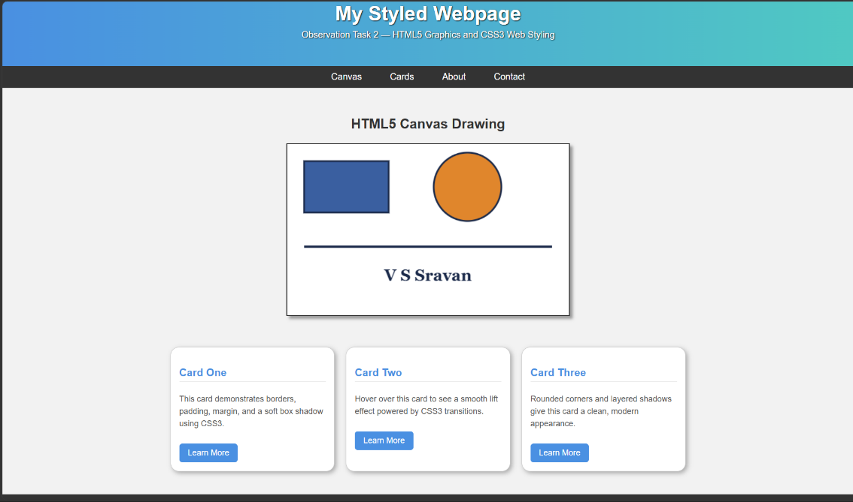
PART-B.html

<!DOCTYPE html>
<html lang="en">

<head>
<meta charset="UTF-8">
<meta name="viewport" content="width=device-width, initial-scale=1.0">
<title>My Styled Webpage</title>
<style>
/* ---------- CSS Syntax & Selectors ---------- */
body {
margin: 0;
padding: 0;
font-family: Arial, sans-serif;
background-color: #f2f2f2;
color: #333333;
}

/* ---------- Header with Gradient Background & Text Shadow ---------- */
header {
background: linear-gradient(to right, #4a90e2, #50c9c3);
color: white;
text-align: center;
padding: 30px 10px;
text-shadow: 1px 1px 2px black;
}

header h1 {
margin: 0;
font-size: 2.2rem;
font-family: Arial, sans-serif;
}

header p {
margin-top: 8px;
font-size: 1rem;
}

/* ---------- Navigation Bar ---------- */
nav {
background-color: #333333;
padding: 10px 0;
}

nav ul {
list-style: none;
display: flex;
justify-content: center;
gap: 30px;
margin: 0;
padding: 0;
}

nav ul li a {
color: white;
text-decoration: none;
font-size: 1rem;
padding: 5px 10px;
}

/* Hover effect for navigation links */
nav ul li a:hover {
background-color: #4a90e2;
color: yellow;
}

/* ---------- Canvas Section ---------- */
.canvas-section {
text-align: center;
padding: 30px 20px;
}

.canvas-section h2 {
font-family: Arial, sans-serif;
color: #333333;
}

canvas {
background-color: #ffffff;
border: 2px solid #333333;
box-shadow: 5px 5px 5px #999999;
}

/* ---------- Content Cards Section ---------- */
.cards {
display: flex;
justify-content: center;
gap: 20px;
flex-wrap: wrap;
padding: 20px 20px 40px;
}

.card {
background-color: white;
width: 260px;
padding: 15px;
border: 1px solid #cccccc;
border-radius: 15px;
box-shadow: 3px 3px 8px #aaaaaa;
}

.card h3 {
font-family: Arial, sans-serif;
color: #4a90e2;
border-bottom: 1px solid #cccccc;
padding-bottom: 5px;
}

.card p {
font-size: 0.9rem;
line-height: 1.5;
color: #555555;
}

.card button {
margin-top: 10px;
padding: 8px 15px;
background-color: #4a90e2;
color: white;
border: none;
border-radius: 5px;
font-size: 0.9rem;
cursor: pointer;
}

/* Hover effect for buttons */
.card button:hover {
background-color: #357ab8;
}

/* ---------- Footer ---------- */
footer {
background-color: #333333;
color: white;
text-align: center;
padding: 15px;
font-size: 0.9rem;
}
</style>
</head>

<body>
<header>
<h1>My Styled Webpage</h1>
<p>Observation Task 2 &mdash; HTML5 Graphics and CSS3 Web Styling</p>
</header>

<nav>
<ul>
<li><a href="#canvas">Canvas</a></li>
<li><a href="#cards">Cards</a></li>
<li><a href="#about">About</a></li>
<li><a href="#contact">Contact</a></li>
</ul>
</nav>

<section class="canvas-section" id="canvas">
<h2>HTML5 Canvas Drawing</h2>
<canvas id="myCanvas" width="500" height="300"></canvas>
</section>

<section class="cards" id="cards">
<div class="card">
<h3>Card One</h3>
<p>This card demonstrates borders, padding, margin, and a soft box shadow using CSS3.</p>
<button>Learn More</button>
</div>
<div class="card">
<h3>Card Two</h3>
<p>Hover over this card to see a smooth lift effect powered by CSS3 transitions.</p>
<button>Learn More</button>
</div>
<div class="card">
<h3>Card Three</h3>
<p>Rounded corners and layered shadows give this card a clean, modern appearance.</p>
<button>Learn More</button>
</div>
</section>

<footer id="about">
<p>&copy; 2026 My Styled Webpage | Created for Observation Task 2</p>
</footer>

<!-- ---------- Part A: HTML5 Canvas Script ---------- -->
<script>
const canvas = document.getElementById('myCanvas');
const ctx = canvas.getContext('2d');

// 1. Rectangle
ctx.fillStyle = '#3a5fa0';
ctx.fillRect(30, 30, 150, 90);
ctx.strokeStyle = '#1b2a4a';
ctx.lineWidth = 3;
ctx.strokeRect(30, 30, 150, 90);

// 2. Circle
ctx.beginPath();
ctx.arc(320, 75, 60, 0, Math.PI * 2);
ctx.fillStyle = '#e0862c';
ctx.fill();
ctx.strokeStyle = '#1b2a4a';
ctx.lineWidth = 3;
ctx.stroke();

// 3. Line
ctx.beginPath();
ctx.moveTo(30, 180);
ctx.lineTo(470, 180);
ctx.strokeStyle = '#1b2a4a';
ctx.lineWidth = 4;
ctx.stroke();

// 4. Name text
ctx.font = "bold 28px Georgia, serif";
ctx.fillStyle = '#1b2a4a';
ctx.textAlign = 'center';
ctx.fillText('V S Sravan', canvas.width / 2, 240);
</script>
</body>

</html>

OUTPUT:
